MINI PROJECT –GPA CALCULATOR

AIM:

To implement a GPA calculator using visual basic 6.0.

ABSTRACT:

In this implementation of GPA calculator the visual basic 6.0 is used to for the creation of forms for the login page of the calculator and for the calculation of the GPA. GPA calculation is done by adding up the products of the subject credit points with the grade points and then divide this sum by the sum of total credit points.

This calculator can only be accessed only if you are registered,for which Microsoft Office Access has been used for the storage of the registration number and date of birth with which you login into the calculator.The login form has been connected with the table in the Access with the help of ADODC .

In the calculation form there are text boxes created for six subjects and three labs. First the user should type the credit points for their subjects and then enter their grade in the corresponding subject. If for a perticular semester there are less than the provided subjects and labs,the user is supposed to give U grade for the subjects or labs that are not there and that subject’s credit point should be given 0. Then calculate button is created with the help of command button and it gives the final calculated GPA.

SOFTWARE REQUIRED:

Microsoft Visual Basic 6.0

Microsoft Office Access

MODULES:

MODULE-1:

Module -1 consists of the form 1,which is the login page. This form has two text boxes one for the registration number and the other for the date of birth of the user. This form is connected to a database in the Microsoft Office Access with the help of an ADODC control so the login will we be successful only when the user is already registered that is their register number and date of birth should be present in the database. The below screen shot shows a sucessful login.

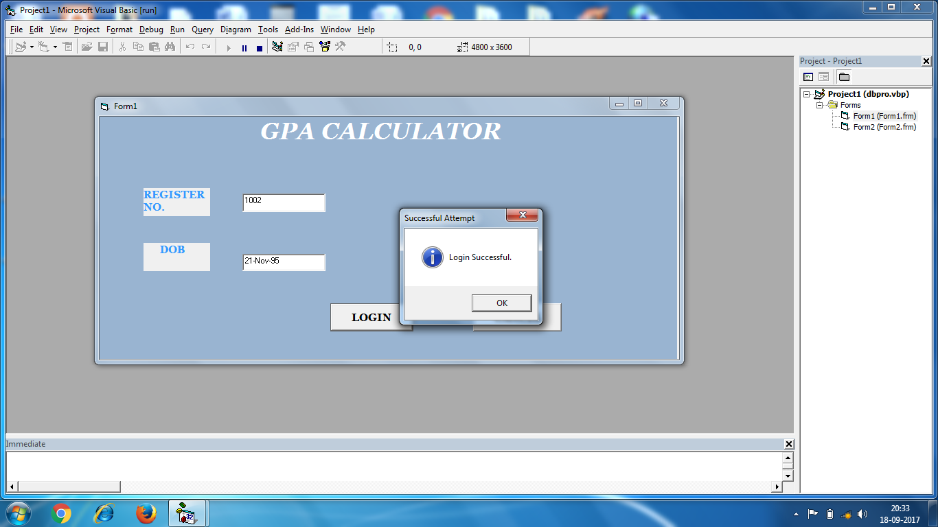

The below screen shot shows an unsuccessful login as the the typed register number and date of birth is not registered.

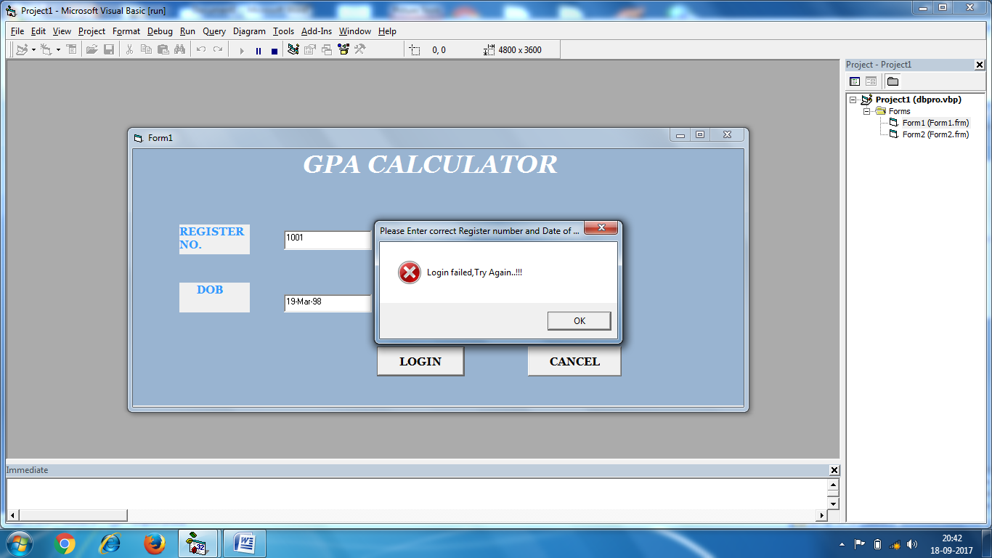

Screen shot of the table in the MS Accesss.

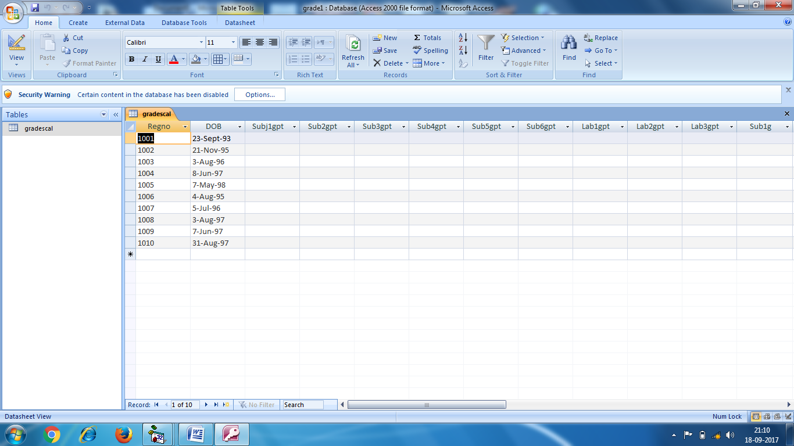

CODE:

CODE FOR THE LOGIN BUTTON:

Private Sub log_Click()

Adodc1.RecordSource = "select * from gradescal where Regno='" + Textreg.Text + "' and DOB='" + (Texdob.Text) + "'"

Adodc1.Refresh

If Adodc1.Recordset.EOF Then

MsgBox "Login failed,Try Again..!!!", vbCritical, "Please Enter correct Register number and Date of birth"

Else

MsgBox "Login Successful.", vbInformation, "Successful Attempt"

Form2.Show

End If

End Sub

CODE FOR THE CANCEL BUTTON:

Private Sub cancel_Click()

Unload Me

End Sub

MODULE-2:

Module -2 consists of the second form which is the calculator form. This form provides eighteen text boxes . Nine text boxes are to get the subject credit points and nine boxes for getting their grades in the corresponding subjects. There are six subjects and three labs .

First the user has to type the subject credit points then type their corresponding grades in those subjects. The grades typed are converted into grade points for the calculation.

If in a semester there are less than six subjects or less than three labs, then the user is supposed to give U grade for that subject and correspondingly that subject’s grade point should be given 0.

In order to obtain the GPA there is a button called calculate which has been created with the help of the command button. This helps in printing the final calculated GPA on the screen.

Screen shot of a calculated GPA.

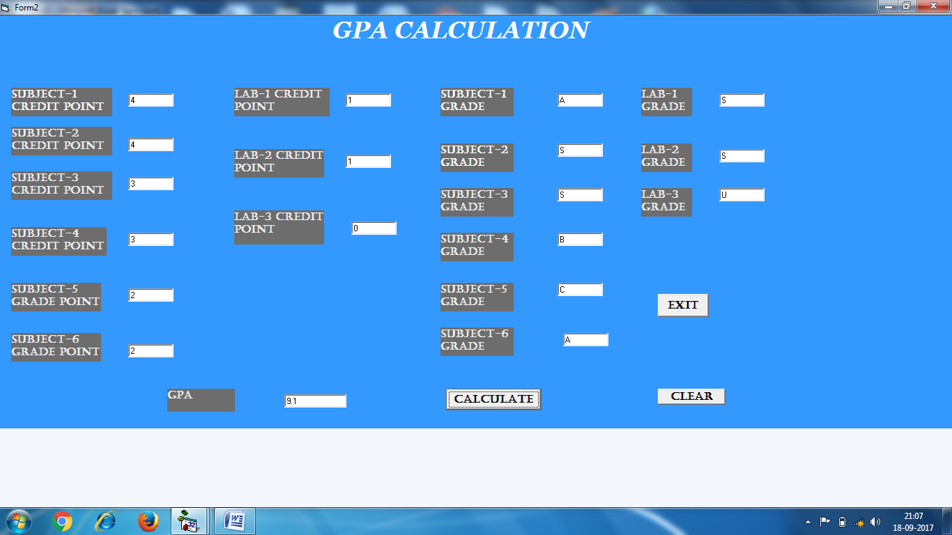

CODE FOR THE CALCULATE BUTTON:

Dim gp1 As Double

Dim gp2 As Double

Dim gp3 As Double

Dim gp4 As Double

Dim gp5 As Double

Dim gp6 As Double

Dim gp7 As Double

Dim gp8 As Double

Dim gp9 As Double

Dim gc1 As Double

Dim gc2 As Double

Dim gc3 As Double

Dim gc4 As Double

Dim gc5 As Double

Dim gc6 As Double

Dim gc7 As Double

Dim gc8 As Double

Dim gc9 As Double

Dim tc As Double

Dim gpa As Double

Private Sub Command2_Click()

gc1 = Text1.Text

gc2 = Text2.Text

gc3 = Text3.Text

gc4 = Text4.Text

gc5 = Text5.Text

gc6 = Text6.Text

gc7 = Text7.Text

gc8 = Text8.Text

gc9 = Text9.Text

If Text10.Text = "S" Then

gp1 = 10

End If

If Text10.Text = "A" Then

gp1 = 9

End If

If Text10.Text = "B" Then

gp1 = 8

End If

If Text10.Text = "C" Then

gp1 = 7

End If

If Text10.Text = "D" Then

gp1 = 6

End If

If Text10.Text = "E" Then

gp1 = 5

End If

If Text10.Text = "U" Then

gp1 = 0

End If

If Text11.Text = "S" Then

gp2 = 10

End If

If Text11.Text = "A" Then

gp2 = 9

End If

If Text11.Text = "B" Then

gp2 = 8

End If

If Text11.Text = "C" Then

gp2 = 7

End If

If Text11.Text = "D" Then

gp2 = 6

End If

If Text11.Text = "E" Then

gp2 = 5

End If

If Text11.Text = "U" Then

gp2 = 0

End If

If Text12.Text = "S" Then

gp3 = 10

End If

If Text12.Text = "A" Then

gp3 = 9

End If

If Text12.Text = "B" Then

gp3 = 8

End If

If Text12.Text = "C" Then

gp3 = 7

End If

If Text12.Text = "D" Then

gp3 = 6

End If

If Text12.Text = "E" Then

gp3 = 5

End If

If Text12.Text = "U" Then

gp3 = 0

End If

If Text13.Text = "S" Then

gp4 = 10

End If

If Text13.Text = "A" Then

gp4 = 9

End If

If Text13.Text = "B" Then

gp4 = 8

End If

If Text13.Text = "C" Then

gp4 = 7

End If

If Text13.Text = "D" Then

gp4 = 6

End If

If Text13.Text = "E" Then

gp4 = 5

End If

If Text13.Text = "U" Then

gp4 = 0

End If

If Text14.Text = "S" Then

gp5 = 10

End If

If Text14.Text = "A" Then

gp5 = 9

End If

If Text14.Text = "B" Then

gp5 = 8

End If

If Text14.Text = "C" Then

gp5 = 7

End If

If Text14.Text = "D" Then

gp5 = 6

End If

If Text14.Text = "E" Then

gp5 = 5

End If

If Text14.Text = "U" Then

gp5 = 0

End If

If Text15.Text = "S" Then

gp6 = 10

End If

If Text15.Text = "A" Then

gp6 = 9

End If

If Text15.Text = "B" Then

gp6 = 8

End If

If Text15.Text = "C" Then

gp6 = 7

End If

If Text15.Text = "D" Then

gp6 = 6

End If

If Text15.Text = "E" Then

gp6 = 5

End If

If Text15.Text = "U" Then

gp6 = 0

End If

If Text16.Text = "S" Then

gp7 = 10

End If

If Text16.Text = "A" Then

gp7 = 9

End If

If Text16.Text = "B" Then

gp7 = 8

End If

If Text16.Text = "C" Then

gp7 = 7

End If

If Text16.Text = "D" Then

gp7 = 6

End If

If Text16.Text = "E" Then

gp7 = 5

End If

If Text16.Text = "U" Then

gp7 = 0

End If

If Text17.Text = "S" Then

gp8 = 10

End If

If Text17.Text = "A" Then

gp8 = 9

End If

If Text17.Text = "B" Then

gp8 = 8

End If

If Text17.Text = "C" Then

gp8 = 7

End If

If Text17.Text = "D" Then

gp8 = 6

End If

If Text17.Text = "E" Then

gp8 = 5

End If

If Text17.Text = "U" Then

gp8 = 0

End If

If Text18.Text = "S" Then

gp9 = 10

End If

If Text18.Text = "A" Then

gp9 = 9

End If

If Text18.Text = "B" Then

gp9 = 8

End If

If Text18.Text = "C" Then

gp9 = 7

End If

If Text18.Text = "D" Then

gp9 = 6

End If

If Text18.Text = "E" Then

gp9 = 5

End If

If Text18.Text = "U" Then

gp9 = 0

End If

tc = gc1 + gc2 + gc3 + gc4 + gc5 + gc6 + gc7 + gc8 + gc9

gpa = ((gp1 * gc1) + (gp2 * gc2) + (gp3 * gc3) + (gp4 * gc4) + (gp5 * gc5) + (gp6 * gc6) + (gp7 * gc7) + (gp8 * gc8) + (gp9 * gc9)) / tc

Text19.Text = gpa

End Sub

MODULE-3:

In this module the operation of the clear button is shown. The clear button is used to clear all the values in the calculator if the user wants to calculate the GPA for another semester. The clear button has been created by the command button. The exit button is also a command button which allows the user to exit from the calculator form and takes the use to the login form.

Screen shot of the clear button.

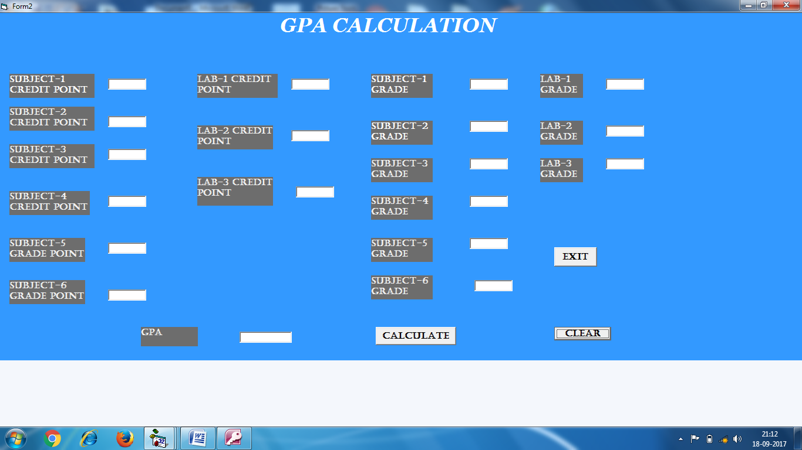

CODE FOR THE CLEAR BUTTON:

Private Sub Command4_Click()

Text1.Text = " "

Text2.Text = " "

Text3.Text = " "

Text4.Text = " "

Text5.Text = " "

Text6.Text = " "

Text7.Text = " "

Text8.Text = " "

Text9.Text = " "

Text10.Text = " "

Text11.Text = " "

Text12.Text = " "

Text13.Text = " "

Text14.Text = " "

Text15.Text = " "

Text16.Text = " "

Text17.Text = " "

Text18.Text = " "

Text19.Text = " "

End Sub

CODE FOR EXIT BUTTON:

Private Sub Command1_Click()

Unload Me

End Sub

RESULT:

A GPA calculator is implemented by designing forms using Microsoft Visual Basic 6.0 and creating table in the Microsoft Office Access.